

BSc Hons in Computing
2024.2
An Explainable Multi-Source Spatiotemporal Model for Traffic Accident Hotspot Prediction and Severity Classification in Sri Lanka

Coventry Index : 16114760
NIBM Registered Name : L.P.N.R.R. Pathirana
NIBM Index : COBSCCOMP24.2P-053

Faculty of Engineering, Environment and Computing
School of Computing, Electronics and Mathematics
Coventry University

School of Computing and Engineering
National Institute of Business Management
Contents
Chapter 1: Introduction 1
1.1 Background 1
1.2 Research Problem 4
1.3 Objectives of the Project 6
1.4 Research Questions 6
1.5 Scope of the Research 7
1.6 Justification of the Research 8
1.6.1 Social Justification 8
1.6.2 Economic Justification 9
1.6.3 Technological Justification 9
1.7 Expected Limitations 10
1.7.1 Data Limitations 10
1.7.2 Time Limitations 10
1.7.3 Geographic Limitations 10
1.7.4 Validation and Contribution Limitations 11
1.8 Chapter Summary 12
Chapter 2: Literature Review 13
2.1 Introduction 13
2.2 Theoretical Background and Conceptual Explanation of Key Concepts 14
2.3 Empirical Review of Previous Studies 18
2.3.1 Machine learning approach to traffic accident analysis and hotspot prediction 18
2.2.2 Crash Severity Prediction and Hotspot Identification using Machine Learning and Spatial Analysis 19
2.2.3 Machine learning approach for classifying road accident hotspots 20
2.2.4 Sri Lankan Accident Hotspot and Severity Prediction Model 21
2.2.5 Explainable AI traffic accident analysis and hotspot prediction 22
2.2.6 Spatiotemporal Risk Mapping of Statewide Weather-related Traffic Crashes: A Machine Learning Approach 23
2.4 The Research Gap 24
2.5 Summary of the Findings 26
2.6 Chapter Summary 28
Chapter 3: Methodology 29
3.1 Introduction 29
3.2 Research Philosophy 31
3.3 Research Approach 33
3.3 Data Collection 34
3.2.1 Historical Police Accident Records 34
3.2.2 Weather Data 36
3.3 ETL Pipeline 38
3.3.1 ETL Pipeline Overview 38
3.3.2 Implementation of Data Lake 40
3.3.3 Geocoding and Location Enrichment Process 41
3.3.4 Weather Data Integration 42
3.3.5 Feature Engineering 43
References 50

Table of Figures

Figure 1 Overview of Methodology 30
Figure 2 Sample Records from Slave Island Police Station 35
Figure 3 Weather Data Collected via Visual Crossing API 37
Figure 4 ETL Pipeline Overview 39
Figure 5 Data Lake Implementation via Mongo Atlas 40
Figure 6 Extracted Location Coordinates via Google Map API 41
Figure 7 Weather Data Integration 42
Figure 8 Assigning H3 cells to each accident record 44
Figure 9 Hotspot Classification via Poisson FDR Approach 47
Figure 10 Implementation of Causal Rolling Spatiotemporal Features 49

Chapter 1: Introduction

1.1 Background
Each year road traffic accidents cause significant damage to human lives and economy. Accordingly, World Health Organization reports that around 1.19 million loses their life as a result of road traffic accident while causing significant number of injuries to individuals. and damages to properties (World Health Organization, 2023). Not only that, but such accidents can also cause economic burden to both the individuals and economy of a relevant country via healthcare expenses, property damage, emergency response cost and etc. (Tandrayen-Ragoobur, 2024).

As a country, Sri Lanka also records a gradual increase in vehicle accidents each year due to factors like urbanization and increased number of vehicle usage. According to the Police Spokesman ASP F.U. Wootler, the number of deaths caused by accidents has increased by 322 compared to 2024, recording 2710 death in the year 2025 (Administrator, 2026). Also similar to other countries, road traffic accident has a significant impact to Sri Lankan economy as well. According to a study by Bhavan (2019), it is found that 1% increase in fatality index can negatively affect the country by declining its economic growth by 0.79%. Additionally, the study by Bhavan (2019) also confirms that road traffic accident contributes to increased health expenditures per capita, placing further restrains on financial resources. This confirms that road traffic accident cause harm not only to individual but also cause damage to the country’s macroeconomic stability.

To reduce negative impacts of road traffic accidents, Sri Lankan government has already taken necessary steps such as introduction of new laws, polices, awareness programs and etc. (Ministry of Transport, n.d.). However, even with such measures, the number of road traffic accidents fluctuates each year due to numerous factors like poor road conditions, reckless driving and excessive speeding (Over 670 Fatal Road Accidents Reported so Far This Year - Sri Lanka Police, 2026). Accordingly, it is clear that such traditional reactive measures alone are not effective, when it comes to road traffic accident preventions in modern Sri Lanka.

However, advancements in computing technologies such as data analytics and machine learning have enabled us with developing predictive frameworks to minimize road traffic accidents. Existing studies have already incorporated machine learning technologies to implement data driven predictive strategies to minimize road traffic accidents. But exploration of such data driven frameworks are extremely limited when it comes to Sri Lanka where accident contributing factors significantly differ from those countries.

Additionally, just incorporating machine learning in safety critical domain has its own problems. One major problem is machine learning model itself are black box systems. This lack of transparency makes it difficult for authorities to incorporate such technologies for accident hotspot prediction. For example, when it comes to safety critical domain such as transportation and road traffic accident, relevant authorities need to know why a certain model made a certain prediction about accident hotspots. However, Explainable Artificial Intelligence frameworks such as SHAP can be incorporated to improve model’s interpretability and thereby it’s transparency (IBM, 2023).

Furthermore, road traffic accidents are cause by combination of factors such as weather data, geographical factors, spatial and temporal events. Among those, existing studies found that weather data play a major role in road traffic accidents. For example, adverse weather conditions such as heavy rainfall, reduce visibility and fog may increase the risk of road traffic accidents (Gorzelanczyk, 2025). It is also found that integrating such contextual weather data can improve a model’s prediction accuracy.

In addition to above discusses factors, road traffics accidents are also not uniformly distributed across locations and time periods. They vary depends on those spatial and temporal features (Wondwossen Taddesse Gedamu et al., 2025). For example, certain location may prone to more accidents during certain time periods or during certain seasonal trends. So, it is very important for authorities to understand how road traffic accident evolves across locations and time periods along with generic accident hotspot prediction. This can be achieved via spatial temporal analysis of accident data, which also improves accident hotspot prediction and severity classification

Accordingly, this research proposes developing of a multi-source machine learning framework for accident risk prediction and spatial analysis in Sri Lanka, which will be integrated with Sri Lankan police accident records and contextual weather data. This framework will help decision making process of the relevant authorities by identifying accident hotspot locations, contributing factors for the accident prediction, dynamic variations across accidents hotspots over a period of time and presenting those information via an interactive dashboard.

1.2 Research Problem
As mentioned earlier, it is very clear that road traffic accidents pose a significant global threat to both human lives and economy of a country. Like every other country Sri Lanka also deals with such negative impacts of road traffic accidents each year. Despites traditional measures such as traffic laws, fines, and signal systems taken by Sri Lankan government to minimize road traffic accidents, statistics shows that number of accidents fluctuates each year with a significant increase in number of road accidents in recent years (Department of Census and Statistics, 2024).

However, with the recent advancements in computing technologies such as predictive analysis using machine learning researchers have already explored using such technologies for accident hotspot prediction and analysis and thereby to enable implementation of predictive framework to minimize road traffic accidents. One of the best examples for this is study done by de et al. (2023), where they developed a predictive framework for accident hotspot prediction in Brazilian Highways using multiple data sources such as location, time and weather conditions. But exploration of such kind of machine learning frameworks are extremely limited when it comes to Sri Lankan context. Moreover, frameworks developed for countries like Brazil are not validated against Sri Lankan context where accident contribution factors such as weather, peak hours and traffic conditions significant differ from such countries.

When it specifically comes to Sri Lankan context, only a limited number of studies have been done on this exact domain. Accordingly, Jayamanna and Kalansooriya (2024) have explored on implementing a machine learning based system that can predict accident hotspots using historical police accident records. But that study was only limited to police accident data source and given no focus when it comes to integrating contextual data sources such as weather data where such contextual data can improve the model’s prediction performance significantly (Yan & Shen, 2022). Accordingly, there is a need for developing a machine learning framework with multiple data sources for Sri Lankan context.

Also as mentioned earlier, occurrence of road accidents are not uniformly distributed across locations and time periods and they vary depends on the location (spatial) and temporal (time) features. So, understating such variation can be very helpful for authorities when it comes to decision making and implementing preventative strategies related to road traffic accidents. Additionally, analysis of such spatial and temporal variation can contribute greatly to the model’s performance (Yan & Shen, 2022). However, to best of my knowledge there are no existing studies have been done on this spatial and temporal analysis when it comes to Sri Lankan context.

As mentioned earlier, another major problem is lack of transparency among machine learning models. As a result, safety critical domains such as transportation hesitate to incorporate machine learning predictive frameworks for accident hotspot prediction and severity classification. However, such issues can be addressed by integrating Explainable AI technologies to machine learning framework as these technologies helps to understand contribution of features to a certain prediction (Al-Omari et al., 2025). But, similar to spatial and temporal analysis of road traffic accident-related data, only a limited number of evidence was found regarding incorporating Explainable AI technologies for accident hotspot prediction and severity classification in Sri Lankan context.

Accordingly, Sri Lanka needs a machine learning framework that uses multiple data sources such as police accident data and weather data for accident hotspot prediction and severity classification. Additionally incorporating analysis of spatial and temporal variation in accident related data Explainable AI technologies can improve both model’s prediction accuracy and transparency.

1.3 Objectives of the Project
- To collect, preprocess and integrate police accident records with contextual weather data into a centralized data warehouse via an ETL pipeline.
- To capture dynamic accident risk variations across regions and time by constructing spatiotemporal features.
- To develop and compare performance of multiple machine learning models such as Logistic Regression, Random Forest and XGBoost to identify the most suitable model when using multiple data sources to predict accident hotspots and classify severity in Sri Lanka.
- To analyze the contribution of spatial and temporal features such as location, time and weather conditions to the accident hotspot prediction and severity prediction using XAI techniques such as SHAP
- To develop a prototype dashboard with necessary API for visualization of predicted hotspot location along with location based filtering and meta data insights that support decision making.

1.4 Research Questions
- How to collect, preprocess and integrate police accident records with contextual weather data and store in a data warehouse via an ETL pipeline?
- How to capture accident risk variation across regions and time using spatiotemporal features such as time patterns and location based grids?
- What is the best machine learning model among Random Forest, Logistic Regression, XGBoost, when it comes to accident hotspot prediction and severity classification in the Sri Lanka using multiple data sources?
- To what extent do the spatial and temporal features such as location, time and weather conditions, contribute to the prediction performance of the model?
- How can a dashboard and an API be developed to visualize the predicted hotspot location along with location-based filtering and metadata insights to support decision making?

1.5 Scope of the Research

The main objective of the research is to develop a multi source explainable machine learning framework for accident hotspot prediction and severity classification in Sri Lanka along with analysis of dynamic variations across accident hotspots using spatial and temporal analysis of road accident data. For the implementation, historical police accident records along with weather data obtained through external APIs based on accident location, time and data will be used. Also the scope of this research will be limited to a selected set of regions due to data scarcity in Sri Lankan context.

The inputs for this research include accident related data such as location, date and time, severity, vehicle involvement, casualties, and cause of the accident along with the contextual weather data, which includes features like precipitation, visibility and temperature. Once collected, these data will go through an ETL pipeline where preprocessing techniques like extraction, transformation, feature engineering and finally integrating to a centralized data warehouse happen. After this, these data will be used to train and evaluate machine learning models such as random forest, Logistic Regression and XGBoost to identify the most suitable for Sri Lankan context.

The final output of the research will be a prototype dashboard and an API with only core functionalities needed for visualization of predicted hotspot location along with location based filtering and meta data insights that support decision making.

Additionally, this framework is developing for authorities such as traffic police authorities and road safety analyst who can use the system to identify hotspot prone areas, contributing factors for predicted accidents and thereby to support data driven decision making.

Also, it is very important to note that this research will be limited only to historical data of selected regions, mainly Colombo Municipal Area as there is no any systematic approach to obtain real time or livestream accident data within Sri Lanka.

1.6 Justification of the Research

1.6.1 Social Justification
As mentioned earlier, road traffic accidents have a significant impact on society in Sri Lanka. Accordingly, each year considerable number of people either suffer from disabilities, serious injuries or even losses their lives due to road accidents. For example, more than 2500 deaths were caused due to road traffic accidents and more than 150000 casualties were receiving in patient treatment due to road traffic accidents in the year 2024 (Siritunga, 2025).

Even though, Sri Lankan government has taken some preventative measures such as traffic laws, awareness programs and other traditional measures to reduce those road traffic accidents, still the impact of road traffic accidents towards social life of Sri Lankans has not significantly reduced. This is because most of such preventative strategies are reactive approaches rather than being proactive approaches. However, our proposed framework helps to identify such accident hotspot and severity of them early, enabling relevant authorities with enough time to take necessary actions such as deploying enough traffic officers, positioning emergency medical services, implementing safety intervention etc. Accordingly, such actions can lead to reduction of number of road traffic accidents and its impact on Sri Lankan society.

1.6.2 Economic Justification
In addition to above mentioned impacts that negatively affects society, road traffic accident also poses a threat to individuals and country’s economy. For example, those accident can cause negative economic impacts such as increased expenses in healthcare and emergency services, vehicle and other property damages, productivity losses due to disabilities and even traffic congestion that can affect supply chain and overall day to day life of people. Also, according to World Bank, it is mentioned that Sri Lanka will need additional USD 2 billion investment by 2030, just to manage road deaths by half and such road traffic accidents can cost around 3-5% of country’s GDP (Siritunga, 2025). However, by predicting accidents earlier with their severity, relevant authorities can take necessary actions earlier to reduce the impact of such accidents and thereby to reduce the above-mentioned negative impacts that affects both directly and indirectly towards individuals and country’s economy.

1.6.3 Technological Justification
When it comes to technological side of the research, most of the existing studies in Sri Lanka has only given focus to accident hotspot and severity prediction with limited exploration towards integration of technologies such as multiple-data source, spatiotemporal analysis, and Explainable AI integration. However, to mitigate such limitations, this research proposes an explainable multi source spatiotemporal framework for hotspot prediction and classify severity of them. Furthermore, even most of the existing studies that integrated Explainable AI only shows the contribution of features to a certain prediction. Even though XAI integrations improves the model’s transparency, such kind of frameworks are still unable to provide intelligent context aware recommendations to the relevant authorities to make the decision making process easier. Accordingly, through the proposed framework, we also address those kinds of limitation by adding a multi agent decision support system and thereby improving practicality of the framework.

1.7 Expected Limitations

1.7.1 Data Limitations
One of the major expected limitations of this research is the limited access to relevant historical traffic accident data within Sri Lanka. Unlike, well developed countries where such data are stored on centralizes data management systems, Sri Lanka manage most of these data still via physical records. Also, most of the records in those physical records were incomplete, inconsistent, and written using Sinhala language, making the data collection process both harder and time consuming. As a result of this limitation, only a very limited number of data were able to collect from Slave Island police station.

1.7.2 Time Limitations
As mentioned above, Sri Lanka still manages traffic accident related via physical records and collection of such data requires a manual effort to go through records books and extracting relevant information. Not only that, but the records were also written in Sinhala language which require additional effort to read handwritten materials and converting them to tabular format which machine learning models understand. However, with the given limited time to complete both the dissertation and artefact, it is unable to invest too much of time just for the data collection phase, which justifies the need for synthetic data. In addition to those, model evaluation is also limited for 1 base model and 2 ensemble model due to this time constraint.

1.7.3 Geographic Limitations
Another major limitation of this research is that is geographically limited to Colombo Municipal Area as result of not having enough data due to previously mentioned data limitations. However, it is supposed to generate synthetic data based on the collected data to address the data limitation issue and to make sure that the framework itself technically works (Lambda Contribution) rather than presenting finding of real-world insights (Omega Contribution) (Gregor & Hevner, 2013). But even those synthetic data is also limited to Colombo Municipal Area as such synthetic data is based on Colombo area’s road network, weather patterns and location structure. So it is better to understand that even technical feasibility (Lambda Contribution) of the framework is implemented by considering Colombo Municipal Area context.

1.7.4 Validation and Contribution Limitations
Another limitation is that Sri Lanka does not have any publicly available traffic accident hotspot or blackspot location maintained by official authorities like Sri Lanka Police. As a result of this, there is no any structured way to validate the findings of the research against official source. So considering factors like data limitations, geographic limitations, validation limitations and most of historical traffic accident data that is supposed to use for model training being synthetic, contribution of the research will be limited to technical aspect (Lambda Contribution) rather than statistical insights or real world accuracy of the predicted hotspots (Omega Contribution) (Gregor & Hevner, 2013).

1.8 Chapter Summary
In today’s world, road traffic accidents are considered as one of the major global threats to both human lives and economy of a country. As a country Sri Lanka also experiences negative effects of road traffic accidents due to several factors such as urbanization, increased vehicle usage and etc. Despites the traditional measures such as implementation of laws and regulations, traffic light systems, awareness programs, fine taken by Sri Lankan government, the number of road traffic accidents grow each year.

However, this chapter introduces our research which uses computing technologies such as machine learning and data analytics to address issues of traditional measures taken to minimize negative effects of road traffic accidents. Additionally, it also explores the usage of Explainable AI technologies along with machine learning models to improve their transparency and thereby to reduce difficulties in adapting such technologies in safety critical domain such as transportation and road traffic accidents.

Furthermore, this chapter also highlights, how such implementation are minimally adapted when it comes to Sri Lankan context, along with an overview of limitations of existing studies.

In conclusion this chapter introduces the proposed explainable multi-source spatiotemporal model for traffic accident hotspot prediction and severity classification in Sri Lanka along with its objectives, research questions and scope of the research. The next chapter will explore existing literatures related to accident hotspots prediction, machine learning, techniques used in hotspot predictions, spatiotemporal modelling and explainable AI technologies along with identification of research gaps on existing studies in related to our proposed implementation.

Chapter 2: Literature Review

2.1 Introduction
As mentioned earlier, road traffic accidents pose a significant threat to human lives and economy of a country. However, researcher have found that it is possible to use computing technologies like machine learning to minimize road traffic accident effectively and efficiently. By using such technologies, it is possible to implement system that can perform tasks like accident hotspot prediction and such implementations can greatly contribute to decision making by authorities, enabling them to take both preventative and effective actions to minimize road traffic accidents.

Accordingly, this chapter will analyze existing studies related to accident hotspot prediction and severity classification using technologies like machine learning, multi-source data integration, Explainable AI, Spatial and Temporal Analysis in related to both global and Sri Lankan context. Furthermore, a comprehensive explanation about research gaps that is found via exploring current studies will also be included in this chapter.

2.2 Theoretical Background and Conceptual Explanation of Key Concepts

2.2.1 Machine learning
Usually, in order to enable computers with decision making capabilities, we have to program every possible scenario related to a certain decision making process via rule based algorithmic techniques. However, with the invention of machine learning (ML), which is a subsection of Artificial Intelligence (AI), it is possible to enable such computer systems to make predictions or decisions by making those computers learn patterns, relationships and structures via historical data without needing the above mentioned rule based algorithmic approaches (Chen, 2024).

Furthermore, machine learning is divided in to 3 approaches, which are namely, supervised, unsupervised and reinforcement learning. Accordingly, when it comes tasks like predicting traffic accident hotspots, it is found that supervised learning is much more suitable as these kinds of tasks require involve learning patterns in historical road traffic data via input variables (features) and output variables (target) (Chen, 2024).

When it comes to using supervised learning approach in this study, it acts as classification task instead of regression as the goal is to label a certain spatial and temporal unit as either a hotspot or not. Also, similar approach has been used when it comes to predicting severity of each hotspot based on the predefined severity assigned to each road accident.

2.2.2 Spatiotemporal Analysis
Events like occurrence of traffic accident depends heavily on geographic locations and the time of the day. However, most of the existing studies implement these kinds of frameworks by considering geographic locations/space (spatial) and time (temporal) as 2 separate entities, which can lead to incomplete predictions. As a solution for this, we can incorporate techniques like spatiotemporal analysis which helps us to understand how patterns related to events like occurrence of road traffic accident hotspots changes with the time and geographic locations (Turab et al., 2026).

Like mentioned earlier, road traffic accidents are not uniformly distributed across geographic locations and time. Instead, many factors like traffic conditions, date, time of the day, weather during the occurrence of the accident, and even historical trends contribute to occurrence of such accident. Therefore, considering only one among spatial and temporal changes can lead to missing detail in each other. Accordingly, by using spatiotemporal analysis, we can enable a machine learning model to learn patterns across both space and time, instead of making it to consider accidents as static events.

Accordingly, when it comes to this study, it implements spatiotemporal analysis via considering factors like time trends related to road accidents, environmental or weather features, and even by creating spatial units via Uber’s H3 Spatial Indexing.

2.2.3 Explainable Artificial Intelligence (XAI)
As mentioned earlier, machine learning can be really good when it comes to predictive performance. However, despite being good at prediction, those machined learning models are considered as black box systems as a result of difficulties in understanding the decision making process of such models by humans. This limited transparency can result in limited adaptation of such technologies in safety critical areas like transportation. As a solution for these kinds of problems Explainable AI (XAI) techniques has been introduced (Ali et al., 2023).

Accordingly, by using XAI, we can understand how a certain prediction is made by a machine model and what input features contributed most for that prediction. Techniques like these, improve the model interpretability and thereby their transparency which helps to improve their adaptation in safety critical domains (Ali et al., 2023).

The specific XAI techniques that we use for this study is SHapley Additive exPlanations (SHAP) which is based on Shapely values from cooperative game theory. Accordingly in this method each feature’s contribution to certain predication is calculated by observing how the prediction of a machine learning changes when features of a dataset added or removed across all possible combinations (Lundberg & Lee, 2017). Moreover, SHAP can provide both global feature explanation, which helps us to understand overall feature importance of the whole dataset and local feature explanation, which helps us to understand each feature’s contribution to a certain predication.

Accordingly when it comes to this study, SHAP is used to understand how feature like spatiotemporal and weather condition contributed to a certain accident hotspot and severity prediction, improving adaptation of such frameworks in safety critical domains such as transportation.

2.2.4 Lambda (Λ) and Omega (Ω) Contribution in Design Science Research (DSR)
Traditional research mostly focuses on understanding or explaining existing phenomena. But when it comes to Design Scient Research (DSR), it involves design, development and evaluation of an artefact that can be used to solve a specific social or organizational problem. Accordingly, this research methodology helps to output a artefact along with proof that the relevant artefact is rigorously evaluated while ensuring its relevance to practical world.

When it comes to DSR project, it can be classified into 2 parts as Lambda (Λ) and Omega (Ω) based on its knowledge contribution. Accordingly, Lambda (Λ) contribution is more focused on delivering technical designs, development, and evaluation of a certain artefact and its more about proving that the relevant artefact can be implemented technically to solve a specific problem. Overall lambda contribution is about outputting a methodological rigorous artifact that is novel, technical feasible and being a product that can solve a real-world problem rather than proving its impact via findings (Gregor & Hevner, 2013).

On the other hand, Omega (Ω) contribution is more focused on real world impact and insights that can be gained after a certain artefact is deployed in a relevant working environment. Unlike lambda contribution which only shows certain artefact can be developed using the method that describe in the dissertation, Omega contribution requires proving the developed artefact can provide real world insights via the output of the artefact and improves organization performance, which requires additional evaluation to make sure that such insights are authentic (Gregor & Hevner, 2013).

When it comes to this study, its more focused on lambda contribution due to some limitation like data scarcity, usage of synthetic data generation and external validation via the organizations like Sri Lanka police itself. As a result of these limitation, this study is going to give lesser or no focus for omega contributions. However, the study will output an artefact that can predict traffic accident hotspots and severity via the usage of technologies like machine learning, XAI, and spatiotemporal analysis that is rigorously tested and evaluated for Sri Lankan context, ensuring a Lambda contribution.

2.3 Empirical Review of Previous Studies

2.3.1 Machine learning approach to traffic accident analysis and hotspot prediction
When it comes to traffic accident analysis and hotspot prediction Santos et al. (2021) has explored using combination of both supervised and unsupervised machine learning technologies for road accident analysis and hotspot prediction in Setúbal district of Portugal.

Accordingly, when it comes to supervised models, Santos et al. (2021) have used several classification technologies such as Decision Trees, Random Forest, Logistic Regression, and Naïve Bayes. Among them, it is found that Random Forest performs better when it comes to accident hotspot prediction. In addition to these classification algorithms, Santos et al. (2021) have also used unsupervised technologies such as Hierarchical Clustering and Density-Based Spatial Clustering of Applications with Noise (DBSCAN) to identify accident prone location clusters. Accordingly, it found that DBSCAN works effectively when it comes to identifying accident prone location clusters.

Furthermore, comparison of multiple machine learning models can be considered as a major strength as in enables evaluation of their performance in accident hotspot prediction. Moreover, it shows that ensemble models such as Random Forest performs well, when it comes to road traffic accident hotspot prediction, enabling us to choose it as a candidate model for our research.

However, this study was conducted in Portugal, which may limit its adaptability when it comes to Sri Lankan context. Also, the study has given limited focus when it comes to Explainable AI techniques and Spatiotemporal modelling of road accident-related traffic data, leaving gaps in implementing such features.

2.2.2 Crash Severity Prediction and Hotspot Identification using Machine Learning and Spatial Analysis
Islam et al. (2022) have also explored on traffic accident hotspot and severity prediction using supervised machine learning approaches. Accordingly, this research was based on Al-Ahsa region of Saudi Arabia. Also, in addition to machine learning approached, researchers have also incorporated Geographic Information System (GIS) based spatial analysis.

Researchers have trained and evaluated 3 supervised machine learning approaches for severity prediction, namely Random Forest, XGBoost, and Logistic Regression. Among them, it is found that Random Forest performed best in their context, achieving 94% accuracy. This study again demonstrates efficiency of supervised machine learning approaches for hotspot and severity prediction. Furthermore, in addition to severity prediction, this study has incorporated Geographic Information System (GIS) based spatial analysis techniques such as Global Moran’s I and Getis-Ord 𝐺∗𝑖 for hotspot identification. Accordingly, results of such analysis highlights that the occurrence of road traffic accidents are based on specific locations with higher risk.

Accordingly, this research shows the importance of combining machine learning models with spatial techniques for severity prediction and hotspot identification and how such framework can benefit transportation authorities in decision making and redcuing road traffic accidents.

However, this research is also limited Saudi Arabian context and not validates against Sri Lankan context. Moreover, usage of Explainable AI techniques and analysis of temporal patterns are highly under explored, leaving gap in combining spatiotemporal analysis along with Explainable AI for accident hotspot prediction and severity classification (Islam et al., 2022).

2.2.3 Machine learning approach for classifying road accident hotspots
de et al. (2023) have already conducted research for identifying road traffic accident locations using supervised machine learning approaches. Additionally, they have also used contextual variables such as weather data that may contribute to traffic accidents.

When it comes to supervised machine learning approaches, de et al. (2023) have used Support Vector Machine (SVM), Random Forest, XGBoost, and Artificial Neural Networks (ANNs) and it is found that ANN performed best with a balanced dataset. Overall researcher highlights that supervised machine learning approaches are effective when it comes to identification of accident hotspots using a balance dataset.

Another strength of this research is the incorporation of external variables such as weather data. Accordingly, it is found that incorporating such variables can improve model’s prediction performance and this proves that same concept can be applied when it comes to Sri Lankan context as such approaches remain underexplored.

Additionally, this study was also given limited focus when it comes to integrating Explainable AI techniques and implementation of frameworks like this are underexplored in Sri Lankan context where weather patterns and peak hours significantly differ from those countries, leaving a gap in adapting such technologies in Sri Lankan context (de et al., 2023).

2.2.4 Sri Lankan Accident Hotspot and Severity Prediction Model
As mentioned earlier only a limited number of studies have been conducted on traffic accident hotspot prediction. One of such studies are a study done by J.M.C.T. Jayamanna & P. Kalansooriya (2024), where they developed a machine learning based mobile application for accident hotspot prediction and severity classification using supervise machine learning approaches.

Accordingly, regression supervised machine learning approaches such as Random Forest Regression, Support Vector Regression (SVR), Gradient Boosting Regression, Decision Tree Regression, and XGBoost Regression were used and evaluated. Among them based on metrices such as Mean Squared Error (MSE) and Mean Absolute Error (MAE), XGBoost Regression was identified as the model with the best performance and chosen as the candidate model for accident hotspot prediction.

When it comes to severity classification, approaches such as Random Forest, XGBoost, and Multi-Layer Perceptron (MLP) classifiers have been used and evaluated using metrices such as accuracy, precision, recall and F1-score. Accordingly, it is found that Random Forest classifier perform best when it comes to accident severity prediction with an accuracy of 68%.

However, this research was highly limited to a single source historical dataset which was obtained from Mount Lavinia police station. Additionally, this study has given a limited focus when it comes to integrating contextual data sources such as weather data which can improve model’s prediction performance. Furthermore, Explainable AI techniques and spatiotemporal analysis of accident data were severely underexplored, leaving a gap in developing multi source framework with Explainable AI technologies such as SHAP and spatiotemporal analysis for accident hotspot prediction and severity classification in Sri Lanka (J.M.C.T. Jayamanna & P. Kalansooriya, 2024).

2.2.5 Explainable AI traffic accident analysis and hotspot prediction
Even though machine learning models can perform predictions related to certain task, it fails to explain how the prediction is made. This is because machine learning models act as black box systems, limiting their adaptability in safety critical domains such as transportation and road traffic accidents due to limited transparency and interpretability. However, to mitigate these kinds of issues researcher have explored on integrating Explainable AI techniques with road accident hotspot prediction systems.

Accordingly, Al-Omari et al. (2025) have explored on integrating Explainable AI technique called SHapley Additive exPlanations (SHAP) with Random Forest to develop a interpretable machine learning model for road accident severity analysis for Irbid region of Jordan. By using SHAP, it is possible to quantify the contribution of each feature for a prediction and thereby to understand the prominent features affecting final accident severity prediction. Accordingly, it is found that speed was the feature that contributed mostly to the traffic accident severity analysis among several environmental and traffic accident-related features.

Accordingly, this study shows the potential of integrating Explainable AI techniques such as SHAP for traffic accident hotpot prediction related tasks. As such integrations, improve model transparency and interpretability by explaining why a certain prediction is made, the relevant users of the system can make informed decisions.
However, such frameworks are also not validated against Sri Lankan context where contribution factors may differ from countries like Jordan, leaving a gap in incorporating such techniques for accident hotspot prediction in Sri Lanka.

2.2.6 Spatiotemporal Risk Mapping of Statewide Weather-related Traffic Crashes: A Machine Learning Approach
As it is mentioned earlier, road traffic accidents are not solely depending on just accident related factors. In fact, contextual spatial and temporal feature like location, time, season and weather contribute heavily to a road traffic accident. But most of the above mentioned studies has given less priority for such analysis of spatial and temporal features. However, by addressing these kinds of limitations, Ogungbire & Pulugurtha (2025) has explored on integrating spatiotemporal risk mapping along with weather related traffic accident hotspot prediction in Nort Carolina region of USA.

Accordingly, for the machine learning model XGBoost was used because of it’s capabilities on capturing complex nonlinear relationships among accident related data variables. Additionally, they have also integrated spatiotemporal analytical techniques such as space-time cube analysis, DTW, and Getis-Ord Gi* to the machine learning model in order to facilitate analysis of road traffic accident variations across both location (spatial) and time (temproal).

When it comes to the findings of the above research, it shows that how incorporating spatiotemporal analysis along with accident hotspot prediction can improve the prediction accuracy of machine learning model as occurrence traffic accidents are not solely based on just traffic accident related data.

However, similar to the above studies, this is also limited to North Carolina region of USA, limiting its adaptability in Sri Lanka where both traffic related data and spatiotemporal variations of traffic accident may differ from such countries. Additionally this research is only limited to weather related crash data, making it less applicable for more generalized traffic conditions and regions. Accordingly, a gap remains in incorporating such techniques for the prediction of road accidents with more genralized causes other than just weather (Ogungbire & Pulugurtha, 2025).

2.4 The Research Gap

According to some of the researches, it is clear that integrating traffic accident data with contextual data such as weather data can significantly improve the prediction performance of the model (Ogungbire & Pulugurtha, 2025; Santos et al., 2021). But when it comes to Sri Lanka, most of the studies rely only on single data source such as historical police accident record. Existing studies related to hotspot analysis in Sri Lanka also suggest that integrating weather related data can have significant impact to hotspot identification and analysis process (Nalaka et al., 2021). Accordingly, Sri Lanka needs a centralized data warehouse integrated with multiple data sources such as police accident records and weather data.

Also when it comes to real world accident occurrence varies across different time periods due to factors like traffic hours, and weather and such factors contributed greatly to the model’s performance prediction (Yan & Shen, 2022). Also according to the study by Ogungbire & Pulugurtha (2025), it is found that spatial and temporal dependencies can improve model’s prediction accuracy. However, this research is only limited to weather related crash data and only a limited number of research has been done on capturing those spatiotemporal variations using features such as time patterns and location based grids, when it comes to broader accident hotspot prediction. Accordingly, a gap remains in combining spatial and temporal features of accidents to create a model that can perform more context aware predictions.

Additionally, most of the existing systems in Sri Lanka were given lesser focus to feature contribution and model explainability analysis. Even though predicting a traffic accident itself is very important, authorities need to know why the model considers a certain location as high-risk hotspot, to support decision making. But machine learning models act as black box systems, limiting their adaptability in safety critical areas. However, it is possible to apply Explainable AI techniques such as SHAP to identify contribution of each feature to the prediction score and thereby it is possible to improve the model’s interpretability (Hamdan & Sipos, 2025; Omar Ibrahim Aboulola, 2024; Islam et al., 2022). But most of the existing research in Sri Lanka has not explored the contribution of features such as location, weather, accident timing and more to predicted accident using explainable AI techniques such as SHAP. Therefore, a gap remains when it comes to model’s interpretability, which is very important for decision making.

Based on above gaps, this study proposes a multi-source explainable spatiotemporal machine learning framework for accident hotspot prediction and severity classification for Sri Lankan context. Also, unlike exiting studies, it is planned to integrate both police accident records and weather data, thus creating a multi source data warehouse. Additionally spatiotemporal analysis via feature engineering to identify variations across accident hotspots and explainable AI techniques such as SHAP will be integrated to improve the model’s prediction performance and interpretability.

2.5 Summary of the Findings
Author | Key Finding | Research Gaps
Santos et al. (2021) | - Random Forest performs best.  - Use multi–Source Data,  - Clustering for hotspot prediction | - No XAI techniques like SHAP  - Limited temporal analysis
de et al. (2023) | - ANN Forest performs best among SVM, RF and ANN.  - Limited spatiotemporal analysis | - Limited explainabilty  - Limited spatiotemporal analysis
Islam et al. (2022) | - Random Forest performs best for severity prediction.  - GIS based hotspot prediction using Global Moran’s I and Getis-Ord 𝐺∗𝑖 | - No XAI techniques like SHAP  - Limited explanatory variables  - Limited spatiotemporal analysis
J.M.C.T. Jayamanna & P. Kalansooriya (2024) | - XGBoost performs best for hotspot prediction  - Random Forest performs best for severity classification | - Single data source  - No XAI techniques  - Limited features  - No spatiotemporal modelling
Al-Omari et al. (2025) | - Random Forest performs best.  - Spatial and temporal pattern analysis  - Feature Importance analysis via SHAP | - Limited to Irbid region of Jordan and not validated against Sri Lankan context
Ogungbire & Pulugurtha (2025) | - Spatiotemporal analysis for risk detection. | - Only limited to weather related crash data.

2.6 Chapter Summary
This chapter consists of a literature review of existing studies related to traffic accident hotspot prediction and severity classification using machine learning models along with multi source data, explainable AI techniques and spatiotemporal analysis.

Accordingly, it is clear that machine learning approaches such as Random Forest, XGBoost, Artificial Neural Network and Support Vector Machines have a overall good performance when it comes to accident hotspot prediction and severity classification. Among them , it is also found ensemble models such as Random Forest and XGBoost performs better with a overall high prediction accuracy.

Furthermore, it is also found that integration of contextual data such as weather can improve model’s prediction performance. In addition to integration of contextual data, it is also revealed that accidents are not uniformly distributed along space (spatial) and time (temporal), instead they vary dynamically depends on space and time, thus requiring a need for spatiotemporal analysis of accident-related features.

Also, as it is mentioned earlier, machine learning models act as black box systems, limiting their adaptation in safety critical domains such as transportation and road traffic accidents where authorities need to know why a certain prediction is made. However, several studies related to this matter also discussed in chapter, explaining how can we use Explainable AI techniques such as SHAP to improve model’s transparency and interpretability and thereby to improve the trust between authorities and the prediction.

However, in this chapter, several gaps related to those existing studies were also discussed. Accordingly, it reveals that most of the existing studies in Sri Lanka given lesser focus to techniques such as multi source data integration, spatiotemporal analysis and integration of Explainable techniques such as SHAP. Thus, this study proposes a multi-source explainable spatiotemporal machine learning framework to predict accidental hotspots and classify severity of them in Sri Lankan context.

Chapter 3: Methodology

3.1 Introduction
This chapter explains the methodology used to design and implement the multi source, explainable spatiotemporal learning machine learning framework for traffic accident hotspot prediction and severity classification in Sri Lanka. Accordingly, a data driven, quantitative and applied research design methodology is adapted for this study as we focus on development of a technical system while evaluating it performance using measurable data and metrices.

Accordingly, this study is structured according to various phases such as data collection, data preprocessing and spatiotemporal feature extraction, machine learning model development and evaluation, integration of Explainable AI techniques and development of the dashboard with necessary APIs, to address the gaps that were identified in previous chapters. Each of these phases are implemented upon one another, ultimately creating a pipeline from raw data ingestion to providing actionable insights in related to identified accident hotspots and their severity via a dashboard.

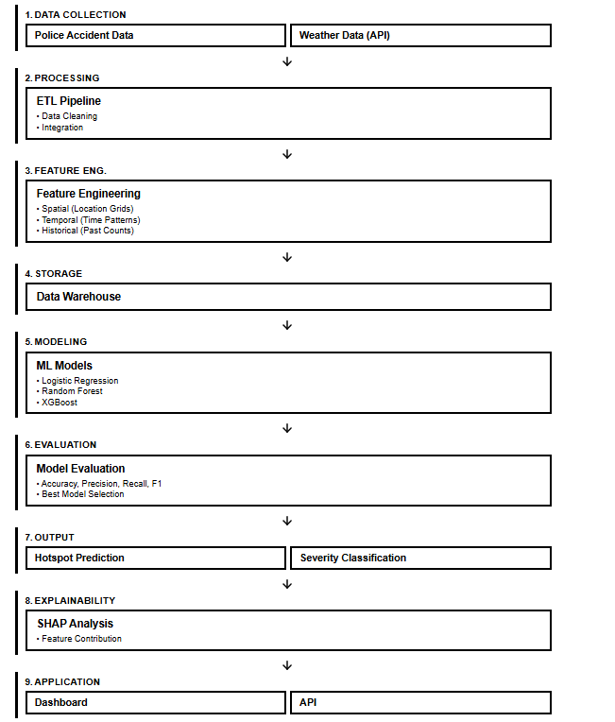
Figure 1 Overview of Methodology

3.2 Research Philosophy

When it comes to conducting certain research, it is very important to understand that it should be done according to a certain set of beliefs and assumption as such beliefs and assumption can affect the way of investigating a research problem, what kind of evidence considered valid and the way interpretation of results of the research. This process of understanding belief and assumption of the research is referring to research philosophy and its simply based on 3 parts, namely, ontology (nature of reality), epistemology (nature of knowledge) and axiology (things that can be considered as valuable during the process).

For this specific study, it is decided to use the pragmatism as the research philosophy as it mainly focusses on addressing real world problems through different kind of approaches that are suitable, when it comes to answering the research questions (Dudovskiy, 2025). Accordingly, as this study more focuses on developing a practical framework for traffic accident hotspot prediction instead of creating or a proving a universal theory, we can clearly say that it comes under the research philosophy pragmatism.

Moreover, the whole study is based on DSR methodology, which can be considered as another reason to choose pragmatism as the research philosophy. This is because studies done according to DSR approach needs to be evaluated on the factors such as study’s effectiveness and usefulness in solving a real world problem. However, it is found that knowledge contribution of a DSR research could be inspected using critical realism instead of pragmatism, it is stated that design and evaluation of the artefact itself needs be evaluated through the perspective of pragmatism as the value of such artefacts is indeed measured by its practical impact (Panakaduwa et al., 2025). Accordingly, it is clear that similar approach has been used when it comes to the implementation of proposed framework as its usefulness is indeed measured by its ability on providing useful insights to relevant authorities (lambda contribution) rather than claiming universal truths.

Also, studies that incorporate pragmatism as research philosophy are allowed to select and combine existence methodologies and technologies in order to solve research questions rather than following established set of traditional methodologies (“Mixing Qualitative and Quantitative Methods,” 2024). Accordingly, the same philosophy has been incorporated into this accident hotspot prediction framework as it combines existing methodologies like Poisson FDR distribution for hotspot identification, supervise machine learning approaches, and integration of SHAP XAI to improve the transparency and interpretability of machine learning models.

Not only that this study also faces some limitations such as data scarcity and usage of synthetic data and due to that research is only limited lambda contribution. So instead of providing ground truths about accident hotspots as the output of the research, it provides a technical framework that is rigorously tested and validated again Sri Lankan Colombo Municipal Area context.

According to the above explanations, it is clear that pragmatism is the most suited research philosophy for this study as it enables this study to follow DSR approach while allowing delivering of a useful artefact that solve real world problems instead of claiming universal theories or ground truths.

3.3 Research Approach
Research approach defines the ways we can use theories and evidences validated through existing studies in related to our own study. Accordingly, such approaches are divided into 3 categories, which are deductive, inductive and abductive. Accordingly, deductive approach refers to testing and validating existing theories via another research while studies done according to inductive approach comes with new theories based on the observations of the study itself. But when it comes to abductive approach, it uses both existing knowledge along with empirical evidence to come up with a solution to a practical problem (Saunders et al., 2023).
Accordingly, for this specific study, it is decided to use abductive approach as the final goal of this research is to output an artefact that addresses a real world problem. Accordingly, this study explores development of a framework that can predict accident hotspot and their severity in order to enable relevant authorities with early decision making ability instead of validating existing theories (deductive) or introducing universal truth via observations (inductive). As mentioned earlier, for this framework it is decided to combine established theories and technologies such as spatiotemporal feature engineering, XIA, statistical hotspot identification and during each stage of implementation of such features relevant design decision were made demonstrating abductive reasoning nature of the study.

Furthermore, previous studies also have shown that abductive reasoning would be a better approach for an artefact based research. For example, Panakaduwa et al. (2025) has mentioned that incorporating abductive reasoning in DSR approach research could be very helpful when it comes identification of research objectives and requirements as it helps to conjoint exiting theories practical problems.

According to the above explanations, it is clear that abductive research approach is the most suited research approach for this study as the final output of the research is about solving a real-world problem by using and combining existing knowledge and based on empirical evidences found on each subsequent stages.

3.3 Data Collection

3.2.1 Historical Police Accident Records

3.2.1.1 Data Collection

The main data source of road traffic accidents is historical road traffic accident data collected from Slave Island police station’s traffic department and those data lays the foundation for the development of traffic accident hotspot prediction and severity classification.

When it comes to data collection, only anonymized necessary data were collected under the guidance of traffic department of Slave Island police station to ensure the data subjects’ privacy and rights. Accordingly collected data includes information such as location, data and time, severity, vehicle types, cause of the accident, no. of fatalities, injuries, property damage and age groups of the accident participant.

However, it is very important to understand that most of the well developed countries have centralized system to manage road traffic accident data. For example USA has a system called Fatality Analysis Reporting System (FARS) which is a centralized system for managing road traffic accident data (NHTSA, 2016). Similarly, Sweden also has a centralized system called Swedish Traffic Accident Data Acquisition (STRADA) which includes data on both road traffic collisions and injuries related those accident (Sweden Study Visit 2020, 2020).

But when it comes to Sri Lankan context, management of such data is still in transitional stage where most of such information are still maintained via physical records while a small portion are digitized. As a result of this most of this information are still not properly centralized. So, the data needed for this study had to be done by manually reviewing and extracting necessary anonymized data in corporation with Slave Island police station. Accordingly, it is very important to understand that collecting a large amount of data in this approach is both time consuming and resource intensive, making it impractical to complete within given time frame.

As a result of such limitation in data management related to road traffic accidents, only a limited number of data was able to be collected from Slave Island police station. Even though those collected data be able to give an idea on real world occurrence of road traffic accidents, such number of limited data is not enough for the training of proposed machine learning models. However, these collected data still provide the foundation for development of proposed machine learning framework.

When it comes to the content of this dataset, it includes all the essential spatial and temporal variables needed for the development of proposed machine learning framework. Accordingly, it includes spatial features such as location and temporal features such as data and time of the road accident occurrence. Other than those, features such as accident severity, vehicle involvement, cause of the accident, age group of drivers that contributed to the accident, cause of accident, collision type, number of fatalities and injuries, were also included and those variables are really important when it comes to identification factors contributed to the hotspot prediction and severity classification.

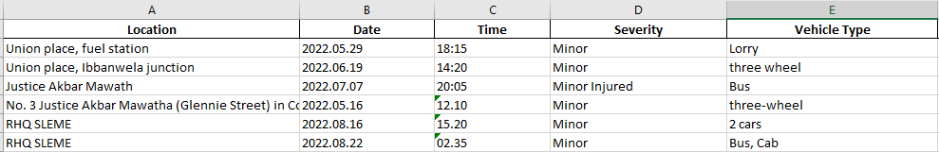
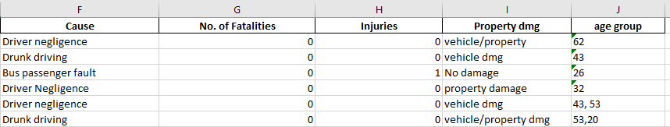
Figure 2 Sample Records from Slave Island Police Station

3.2.1.2 Synthetic Data Generation

As it is mentioned earlier, only a limited number of data were collected from Slave Island police station due to factors like not having a proper centralized data management system and still having those data in physical record books. Even though these data provides the foundation for the development of proposed framework, such limited number of records are not enough for the training of relevant machine learning models as they generally require sufficient number of records to learn patterns without causing underfitting (developer, 2024).

3.2.2 Weather Data
As mentioned in previous chapters, it is clear that integrating contextual data like weather data can improve model’s prediction performance. Accordingly, a weather dataset that covers the Colombo Area from the year 2022-2025 is obtained via Visual Crossing Weather API, thus developing a multi source machine learning framework for traffic accident hotspot prediction and severity classification in Sri Lanka (Weather Data & Weather API | Visual Crossing, n.d.). The integration of such data enables the model with more context and thereby improving its prediction performance. Also, by using this method, it is also possible to identify environmental factors that contribute for a certain road traffic accident. Furthermore, this dataset also aligns with the duration of road traffic accident dataset, ensuring it is associated with relevant historical traffic accident data record during the merging process.

Accordingly collected weather data includes features like weather condition (cloudy, rainy, partly cloudy ), precipitation, visibility, humidity, cloudcover, sunrise and sunset, enriching police accident dataset with environmental factors.Also, in addition to those mentioned features, feature engineering has performed to derive columns like weather_condition_label (cloudy, partly cloudy, heavy and light rain) based on precipitation value and visibility_level (good, moderate and poor) based on visibility values to provide more interpretable feature for machine learning models.

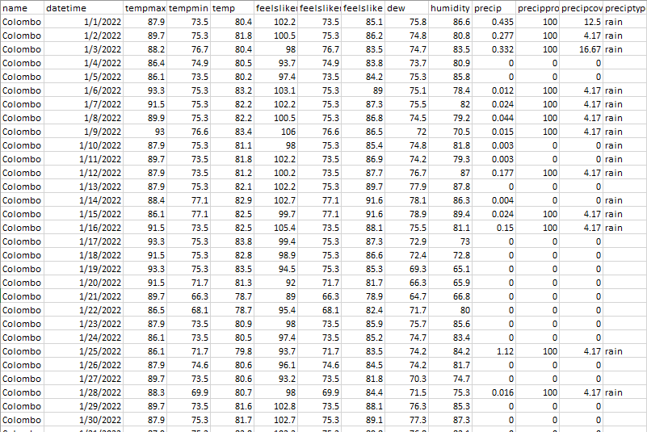
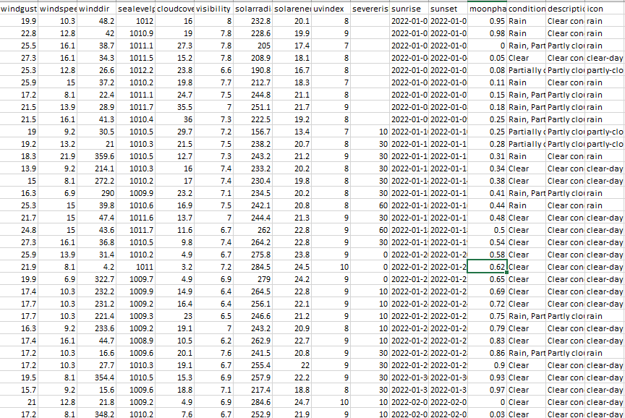

Figure 3 Weather Data Collected via Visual Crossing API

3.3 ETL Pipeline

3.3.1 ETL Pipeline Overview

Once data collection is done, the collected data will go through an ETL pipeline in order to prepare those data for machine model training and evaluation. By incorporating this approach, we can automate the processes such as data extraction from multiple sources such as historical police accident records and weather data, feature engineering and transforming these data into a consistent format that the relevant machine models can understand and load them into a centralized data warehouse.

When it comes of implementation of ETL pipeline, the first and foremost step is ingesting raw data to a data lake implemented using Mongo Atlas, thus creating a data source with raw data needed for the ETL pipeline. This ensures a more scalable approach to when it comes data management.

Accordingly, this ETL pipeline will ensure that the relevant data will undergo preprocessing techniques such as data cleaning, handling missing values, standardization of data formats to a consistent one as they obtained from multiple sources etc. Also, the longitudes and latitudes relevant to each location will be also obtained via Google Map API, thus implementing the foundation for accident hotspot prediction and spatial analysis. Once this is done, the next step of the ETL pipeline is merging the traffic accident dataset with weather dataset based on the data and time, creating the multi-source dataset with enriched context for model training.

Once the above steps are completed, feature engineering will be performed to obtain additional features that could explain an occurrence of an accident with more context. This includes conventional features such as weather categories, temporal features such as day of the week, month, holiday indicators and spatial features such as location-based grids and etc. By doing this, it is possible to identify relationships between spatial and temporal features in related to a certain accident, thus enriching the models with more context.

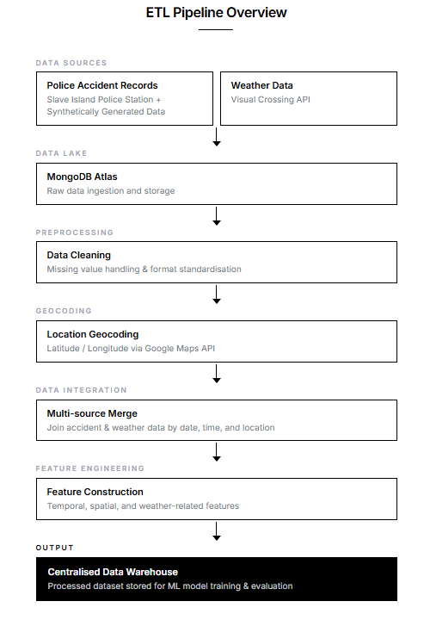
As the final step of the ETL process, the process data will be loaded to a data warehouse, creating centralized source of data for traffic accident hotspot prediction and severity classification.
Figure 4 ETL Pipeline Overview

3.3.2 Implementation of Data Lake
Before conducting any preprocessing techniques to the collected data, first such data will be inserted to a data lake hosted on Mongo Atlas. Accordingly, both the raw historical police accident records and weather data obtained via Visual Crossing Weather API, which is in CSV format will be converted to JSON format via a python script in order to make sure that such data is stored in Mongo Atlas data lake without compromising or changing the obtained data. Once converted, those data will be stored in 2 sperate independent MongoDB collections, namely raw_accidents and raw_weather. Moreover, functions like MongoDB upsert operations are used to prevent duplication of data during multiple insertions. This ensures only new data is inserted to the data lake during the ingestion. Accordingly, implementing data lake like this ensures a centralized data storage mechanism for raw data and it also helps in processes such as data traceability, reproducibility and reprocessing which are considered as advantageous of having data lake for machine learning framework like proposed artefact (What Is Data Lake Architecture?, 2024).

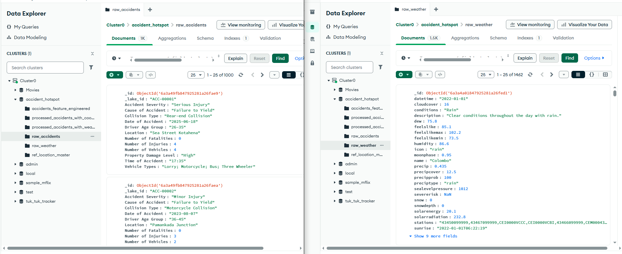
Figure 5 Data Lake Implementation via Mongo Atlas

3.3.3 Geocoding and Location Enrichment Process
Once raw data ingestion to the data lake is completed, next step of the ETL process is to geocode the collected historical police accident records. As mentioned earlier, these accident data are still recorded in physical books and as a result of this manual process, location coordinates for given locations were never included. But when it comes to our implementation such location coordinates are one of mandatory features needed for hotspot prediction and spatial analysis. So, as one of the first stage of ETL pipeline, we geocode those location data in historical police accident records with the help of Google Map API (Geocoding API Overview, 2025).

Accordingly, when it comes the implementation, only the unique location coordinates in the dataset are retrieved. Once done, such location coordinates are stored in a reference collection called location_master in Mongo Atlas. Accordingly, this reference collection act as caching layer for location coordinates and it helps to avoid redundant API calls by only retrieving new unique location coordinates upon subsequent requests by comparing them with the existing location coordinates in location_master reference collection. Moreover, during this process standardization of locations will also be performed to ensure consistency and integrity of location names. Once, above mentioned stages are completed, the processed dataset with both standardized locations and geo coordinates is saved in a MongoDB collection called processed_accidents_with_coords which is hosted on Mongo Atlas.

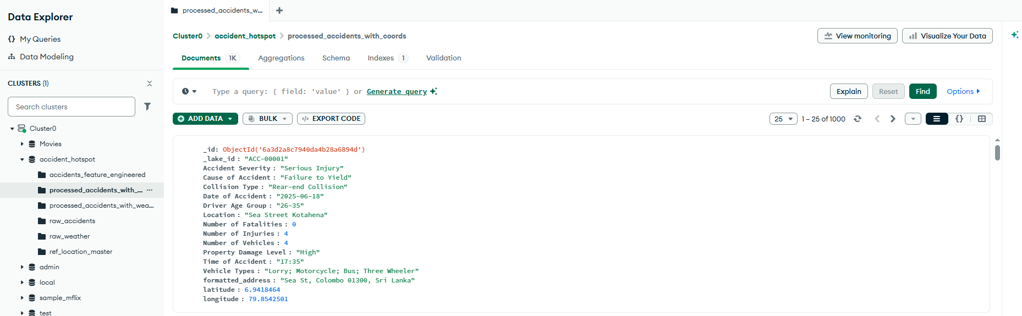
Figure 6 Extracted Location Coordinates via Google Map API

3.3.4 Weather Data Integration
Once the geocoding of historical traffic accident data is completed, the next step of the ETL pipeline is to merge the contextual weather data along with the traffic accident data. Accordingly, the raw weather data which is stored in MongoDB data lake is retrieved to extract useful features such as precipitation, visibility, humidity, cloud cover, sunrise and sunset times from the raw dataset. In addition to raw features, feature engineering has performed to extract additional features such as visibility levels/description and light conditions to make the interpretation of such features easier for machine learning models. Once these steps are completed, the processed weather dataset is merged into historical accident dataset based on their dates and stores in a separate collection called processed_accidents_with_weather in Mongo Atlas.

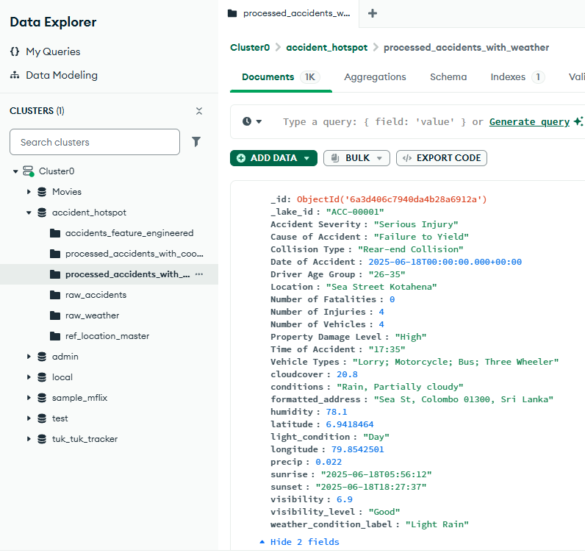
Figure 7 Weather Data Integration

3.3.5 Feature Engineering

3.3.5.1 Conventional Feature Engineering

3.3.5.2 Spatiotemporal Feature Engineering
As mentioned earlier, road traffic accidents are not uniformly distributed through the space and time. So understanding such variation and having contextual awareness in space and time can genuinely benefit a machine learning when it comes to predicting reliable traffic accident hotspots and their severity.

3.3.5.2.3 Spatial Indexing via H3 Hierarchical Hexagonal grid

When it comes to hotspot identification, standalone location coordinates of each accident that we geocoded via Google Map API in geocoding stage is not enough due to inability of such coordinates in understanding spatial context of road accident hotspots and not being aware about neighborhood context.. Because of this, it is decided to use Uber’s H3 hierarchical hexagonal indexing and transform this individual location coordinates of road accidents to spatial units (“H3: Uber’s Hexagonal Hierarchical Spatial Index,” 2026). The reason for choosing this specific Uber’s H3 indexing instead of square grid is because square grid introduces corner adjacency differences resulting in variations in distance between neighboring cells. However, such problems are not applicable to Uber’s H3 indexing as they use hexagonal shaped grids which enables all 6 adjacent cells to share an edge with a central H3 index while being approximately equidistant (“H3: Uber’s Hexagonal Hierarchical Spatial Index,” 2026). This is very important when it comes to understanding context of neighboring cells for spatial analysis. By doing this, we can make sure that each accident location coordinate gets assigned to a unique hexagon according to a predefined resolution along with analysis of neighborhood H3 cells for accident hotspot identification.

When it comes to implementation each longitude and latitude related to a road traffic accident is mapped to cell via using the function give below,
c_{i​} = H3(lat_{i}​,lng_{i}​,r)

Accordingly, in here C_{i} represent the cell identifier for a given accident “i” and “r” represent the resolution at which the each cells are represented.

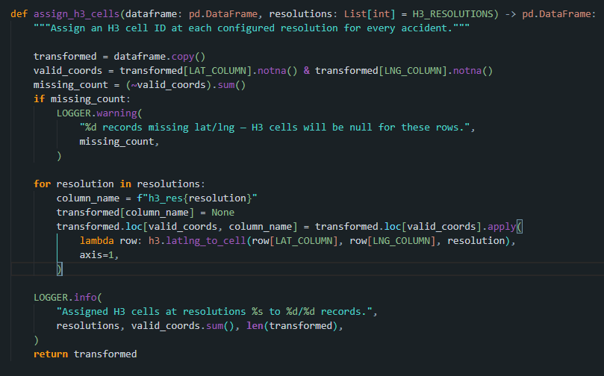
Figure 8 Assigning H3 cells to each accident record

Moreover, when it comes to H3 resolution selection (r), initially we selected 2 candidate H3 resolutions which are resolution 8 and 9. However, after comparing both, it is decided to select resolution 8 as primary resolution, where each H3 cell covers and approximate area of 0.737km² (“Tables of Cell Statistics Across Resolutions | H3,” n.d.). This is because choosing higher resolution for a cell can cause problems such as spatial sparsity due to the limited number of data causing most of the cells to have a zero or limited number of accidents, enabling such cells to act almost as individual location coordinates. Therefore, resolution 8 has chosen which acts a balance of both ends making it much more suitable for spatial analysis of a area like Colombo Municipal Area.

3.3.5.2.4 Spatial Aggregation and Hotspot Classification

So in order to predict traffic accident hotspots and thereby to satisfy the relevant objectives, first we need to setup hotspot labels itself for the relevant data points. Accordingly, by using the same H3 indexing approach that we discussed above, each accident is inserted to a H3 cell based on their geo coordinates along with total accident counter per each cell.

Accordingly, under null hypothesis of Complete Spatial Randomness (CSR), we expect a certain number of accidents to be included in each cell based on the average accident rate that we calculated using the total number of accidents in the collected dataset. However, if a certain H3 cell has significant higher number of accident count than this expected average, then that H3 cell is labelled as a hotspot. The reason for using this method instead of arbitrary percentile based threshold because such constant thresholds are unable to provide any statistics for the chosen percentile.

When it comes to calculating expected average accident count for each cell based on CSR, we use Poisson distribution with rate parameter lambda (λ) being equal to the mean accident count of all H3 cells:

$$λ=\frac{1}{\left|C\right|}\sum_{c∈C}{n_{c}}$$

Accordingly, in here,
  - C represent H3 Cells with at least one Accident,
    - Therefore |C| = Total Number of Cells with at least one Road Accident
  - n_{c} = Number of Accident inside cell “c” ("c” is a selected individual cell in here)

Once (λ) is calculated, a “P-Value” for each H3 cell is calculated to get the probability of having same accident count or greater (as much as n_{c} in the above equation) than (λ) via using the below null model:

$$p_{c}=P\left(X≥n_{c} ∣ X∼\text{Poisson}\left(λ\right)\right)=1-F_{\text{Poisson}}\left(n_{c}-1;λ\right)$$

Accordingly, in here,
  - P_{c} = Probability of having same accident count or greater than the observed accident count in n_{c} for cell “c”. For this we have to assume that accidents are randomly spread across the study area.
  - X = Random variable that is used to represent expected accident count for a cell “c” according to Poisson distribution.
  - $\text{Poisson}\left(λ\right)$ = Poisson distribution with the above calculated (λ) as expected average accident count per cell
  - $F_{\text{Poisson}}$ = Cumulative Distribution function of the Poisson which is used to calculate the probability of getting a value less than or equal to a given accident count

Accordingly, if we get a small P-Value (P_{c}) for a given cell, that means the accident count that we have is highly unlikely to happen according to spatial randomness. This means that specific H3 cell could be a potential hotspot.

However, during the identification of above mentioned hotspots, it is clear that we had to perform statistical test for each and every cell. This kind of multiple hypothesis tests can lead to increased number of false positive rate. As a solution for this problem Benjamini-Hochberg False Discovery Rate (FDR) correction is used to adjust the above calculated P-Values to make the hotspot labelling process stricter (Benjamini & Hochberg, 1995).

Accordingly, when it comes to applying Benjamini-Hochberg FDR, calculated P-Value were ranked in ascending order and each of them were compared against the threshold value calculated using the below equation.
$$p_{\left(k\right)}≤\frac{k}{m}α$$

Accordingly, in here,
  - k = Rank of the P-Value (after reordering in ascending order)
  - m = Total number of H3 cells tested.
  - $α$ = Significance level (0.05 in this case)

Once calculated, H3 cells with adjusted P-Value below the 0.05 were decided to label as accident prone hotspots.

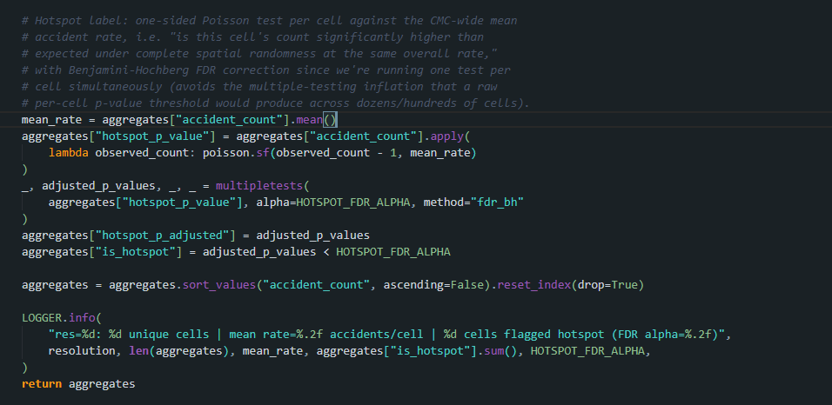
Figure 9 Hotspot Classification via Poisson FDR Approach

3.3.5.2.5 Causal (Leakage Safe) Rolling Spatiotemporal Features

The hotspot labels that we generated in the above process via the road accident records covers the whole timeline of the dataset. However, providing that kind of whole history for given H3 cell as an input to a machine learning model can cause severe problems like data leakage (IBM, 2024). For example, model is not supposed to know the hotspot status for a given H3 cell for the data 20th of June 2026, when it’s supposed to predict the hotspot status for that date.

Accordingly, as a solution to such kind of problems, spatiotemporal temporal features were engineered using causal (temporarily ordered) formula. By doing this we can make sure that only prior accident records for a given accident event are provided to the relevant machine learning model and thereby preventing leakage of outcome of a certain prediction as a feature.

When it comes to implementation of such features, it is decided to implement 2 kinds of spatiotemporal features for both same cell and its neighbor cells with the trailing time windows of 30,90 and 180 days respectively.

- Rolling Spatiotemporal Features for Same H3 Cell

$${\text{same}\text{_}\text{cell}\text{_}\text{count}}_{i}\left(w\right)=\left|\{j:c_{j}=c_{i}, t_{i}-w≤t_{j}<t_{i}\}\right|$$

In here,
  - w = Time Windows (30,90 and 180 days)
  - C_{i} = H3 Cell that containing a given accident “i”
  - C_{j} = H3 Cell that containing a previous accident “j” for a given accident “i”
  - T_{i} = Time of accident “i”
  - T_{j} = Time of accident “j”

Accordingly, this gets the number of previous accidents for same H3 cell for a given time window.
- Rolling Spatiotemporal Features for neighbor H3 Cell (Spatial Lag)

$${\text{neighbor}\text{_}\text{count}}_{i}\left(w\right)=\{j:c_{j}∈N\left(c_{i}\right), t_{i}-w≤t_{j}<t_{i}\}$$

In here the only difference is
  - $N\left(c_{i}\right)$ which is used to depict first order neighboring H3 cells for a given H3 cell. In here the given H3 cell itself is excluded.

Accordingly, this gets the number of previous accidents for neighboring H3 cell for a given time window.

In both above occasions, $t_{j}<t_{i}$ make sures that only prior accidents for a given accident event are included for the relevant feature engineering, while preventing data leakage by ignoring the given accident itself and its future events.

The outcome of this stage is 6 causal spatiotemporal features for each accident that helps machine learning models to learn patterns related to road traffic accident in both same H3 cell and its neighboring cells.

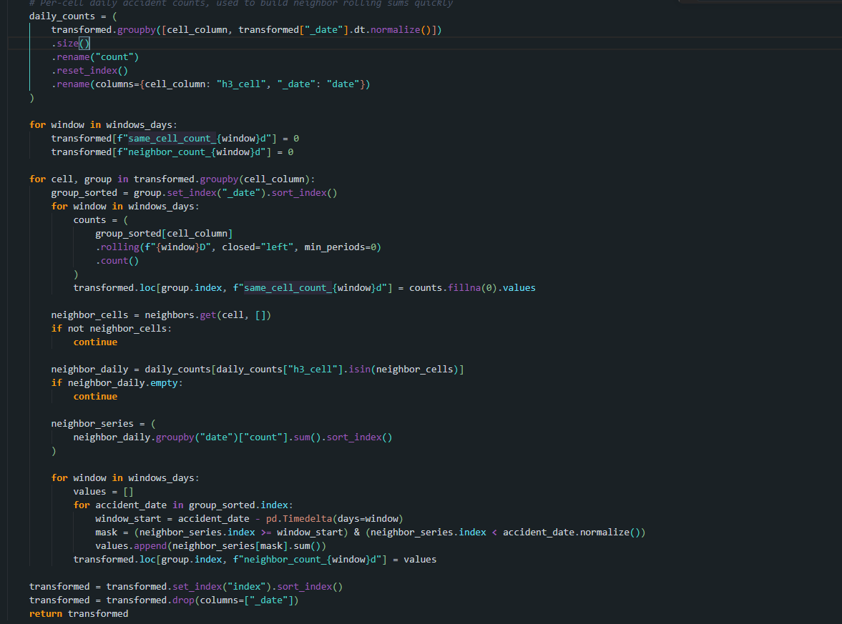
Figure 10 Implementation of Causal Rolling Spatiotemporal Features

References

Administrator. (2026). Road accident deaths rise in 2025. Dailymirror.lk; Dailymirror. https://www.dailymirror.lk/breaking-news/Road-accident-deaths-rise-in-2025/108-329246

Ali, S., Abuhmed, T., El-Sappagh, S., Muhammad, K., Alonso-Moral, J. M., Confalonieri, R., Guidotti, R., Ser, J. Del, Díaz-Rodríguez, N., & Herrera, F. (2023). Explainable Artificial Intelligence (XAI): What we know and what is left to attain Trustworthy Artificial Intelligence. Information Fusion, 99(101805), 101805. sciencedirect. https://doi.org/10.1016/j.inffus.2023.101805

Al-Omari, A., Alsaleh, M., & Shatnawi, N. (2025). Spatial-Temporal Analysis and Severity Prediction of Traffic Accidents. Engineered Science. https://doi.org/10.30919/es1472

Bhavan, T. (2019). The Economic Impact of Road Accidents: The Case of Sri Lanka. South Asia Economic Journal, 20(1), 124–137. https://doi.org/10.1177/1391561418822210

Benjamini, Y., & Hochberg, Y. (1995). Controlling the False Discovery Rate: A Practical and Powerful Approach to Multiple Testing. Journal of the Royal Statistical Society: Series B (Methodological), 57(1), 289–300.

Berhanu, Y., Dietrich Schröder, Bikila Teklu Wodajo, & Alemayehu, E. (2024). Machine Learning for Predictions of Road Traffic Accidents and Spatial Network Analysis for Safe Routing on Accident and Congestion-Prone Road Networks. Results in Engineering, 102737–102737. https://doi.org/10.1016/j.rineng.2024.102737

Chen, M. (2024). What Is Machine Learning? In Oracle.com. Oracle. https://www.oracle.com/apac/artificial-intelligence/machine-learning/what-is-machine-learning/

de, B., Anderson Almeida Firmino, de, C., Geraldo Braz Junior, Anselmo, & Edeverton, F. (2023). A Machine Learning Approach for Classifying Road Accident Hotspots. 12(6), 227–227. https://doi.org/10.3390/ijgi12060227

Department of Census and Statistics. (2024). Statistics.gov.lk. https://www.statistics.gov.lk/abstract2024/chapter7

developer. (2024, July 23). How Much Training Data is Needed for Machine Learning? - unidata.pro. Unidata.pro. https://unidata.pro/blog/how-much-training-data-is-needed-for-machine-learning/

Dudovskiy, J. (2025). Pragmatism Research Philosophy - Research-Methodology. In Business Research Methodology. https://research-methodology.net/research-philosophy/pragmatism-research-philosophy/

Geocoding API overview. (2025). Google for Developers. https://developers.google.com/maps/documentation/geocoding/guides-v3/overview

Gorzelanczyk, P. (2025). Impact of weather conditions and road type on traffic safety. European Transport Studies, 2, 100042. https://doi.org/10.1016/j.ets.2025.100042

Gregor, S., & Hevner, A. R. (2013). Positioning and Presenting Design Science Research for Maximum Impact. MIS Quarterly, 37(2), 337–355. https://doi.org/10.25300/misq/2013/37.2.01

H3: Uber’s Hexagonal Hierarchical Spatial Index. (2026). In Uber. https://www.uber.com/us/en/blog/h3/

Hamdan, N., & Sipos, T. (2025). Advancements in Machine Learning for Traffic Accident Severity Prediction: A Comprehensive Review. Periodica Polytechnica Transportation Engineering, 53(3), 347–355. https://doi.org/10.3311/pptr.40369

IBM. (2023, March 29). Explainable AI. IBM. https://www.ibm.com/think/topics/explainable-ai

IBM. (2024). Data leakage machine learning. In Ibm.com. https://www.ibm.com/think/topics/data-leakage-machine-learning

Islam, Md. K., Reza, I., Gazder, U., Akter, R., Arifuzzaman, M., & Rahman, M. M. (2022). Predicting Road Crash Severity Using Classifier Models and Crash Hotspots. Applied Sciences, 12(22), 11354. https://doi.org/10.3390/app122211354

J.M.C.T. Jayamanna, & P. Kalansooriya. (2024). Development of an Intelligent Road Safety Mobile Navigation Application Using Machine Learning for Real-Time Accident Hotspot and Severity Prediction: A Case Study in Sri Lanka. 5th International Conference on Advances in Highway Engineering & Transportation Systems 2024, 17–35. https://doi.org/10.31705/ICAHETS.2024.8

Lundberg, S., & Lee, S.-I. (2017). A Unified Approach to Interpreting Model Predictions. In arXiv.org. https://doi.org/10.48550/arXiv.1705.07874

Ministry of Transport. (n.d.). Www.transport.gov.lk. https://www.transport.gov.lk/web/index.php?lang=en

Mixing Qualitative and Quantitative Methods. (2024). Cambridge University Press eBooks, 117–134. https://doi.org/10.1017/9781009031066.007

Nalaka, P. K., Akther, M. S. R., & Naveendrakumar, G. (2021). Accident Hotspots in Southern Expressway of Sri Lanka: Interpolation Evaluation using GIS. Advances in Technology, 1(1). https://doi.org/10.31357/ait.v1i1.4835

NHTSA. (2016, November 14). NHTSA. https://www.nhtsa.gov/research-data/fatality-analysis-reporting-system-fars

Ogungbire, A., & Pulugurtha, S. S. (2025). Spatiotemporal Risk Mapping of Statewide Weather-related Traffic Crashes: A Machine Learning Approach. Machine Learning with Applications, 100642. https://doi.org/10.1016/j.mlwa.2025.100642

Omar Ibrahim Aboulola. (2024). Improving traffic accident severity prediction using MobileNet transfer learning model and SHAP XAI technique. PloS One, 19(4), e0300640–e0300640. https://doi.org/10.1371/journal.pone.0300640

Over 670 fatal road accidents reported so far this year - Sri Lanka Police. (2026). Adaderana.lk. https://www.adaderana.lk/news.php?nid=120831

Panakaduwa, C., Coates, P., Munir, M., & Samansiri, S. (2025). Examining the Philosophical Underpinnings of Design Science Research (DSR). Philosophies, 10(6), 139. https://doi.org/10.3390/philosophies10060139

Santos, D., Saias, J., Quaresma, P., & Nogueira, V. B. (2021). Machine Learning Approaches to Traffic Accident Analysis and Hotspot Prediction. Computers, 10(12), 157. https://doi.org/10.3390/computers10120157

Saunders, M., Lewis, P., & Thornhill, A. (2023). Research Methods for Business Students (9th ed.). Pearson.

Siritunga, T. L. S. S. (2025). Road traffic crashes in Sri Lanka: an epidemic that demands multisectoral public-health mobilization. Journal of the College of Community Physicians of Sri Lanka, 31(4), 116–121. https://doi.org/10.4038/jccpsl.v31i4.8902

Sweden study visit 2020. (2020). ETSC. https://etsc.eu/projects/eu-road-safety-exchange/study-visits-and-workshops/sweden-study-visit-2020/

Tables of Cell Statistics Across Resolutions | H3. (n.d.). In h3geo.org. Retrieved July 21, 2026, from https://h3geo.org/docs/core-library/restable/

Tandrayen-Ragoobur, V. (2024). The Economic Burden of Road Traffic Accidents and Injuries: A Small Island Perspective. International Journal of Transportation Science and Technology. https://doi.org/10.1016/j.ijtst.2024.03.002

Turab, D., Muzaffar, S., Nadeem, L., Li, J., Wang, Y., Mahmood, T., & Saba, T. (2026). Data-driven analysis and prediction of traffic accident dynamics using spatiotemporal modeling and optimized machine learning techniques. International Journal of Data Science and Analytics, 22(1). https://doi.org/10.1007/s41060-025-00938-1

Weather Data & Weather API | Visual Crossing. (n.d.). Www.visualcrossing.com. https://www.visualcrossing.com/

What Is Data Lake Architecture? (2024). MongoDB. https://www.mongodb.com/resources/basics/databases/data-lake-architecture

‌ Wondwossen Taddesse Gedamu, Wiedenbeck, U. P., & Bikila Teklu Wodajo. (2025). Spatio-Temporal Analysis of Road Traffic Crashes by Severity. Transportation Engineering, 20(2), 100327. https://doi.org/10.1016/j.treng.2025.100327

Yan, M., & Shen, Y. (2022). Traffic Accident Severity Prediction Based on Random Forest. Sustainability, 14(3), 1729. https://doi.org/10.3390/su14031729

